Audio Builders Workshop

555 Metronome built on BREADBOARD KIT

### Introduction

This documents describes a project that can be built with the ABW breadboard kit. You should read the documents provided with that before building this circuit as those documents explain details about how to use a breadboard and identify the parts.

This example is intended as a beginner level to introduce you to assembling your own electronic projects. If you received this kit at an AES/ABW event then most likely there are volunteers on hand to answer questions while you follow this guide to assemble the kit.

If you received this kit for assembly at home many general electronic assembly questions can be answered from resources found on the internet.

If you get stuck and need help please post your question on the Audio Builders Workshop’s Facebook page <https://www.facebook.com/groups/AudioBuildersWorkshop/>

Looking for the projects? Please see:

<https://github.com/AudioBuildersWorkshop/BreadboardKit/>

### About the audio builders workshop (ABW)

The ABW is a working group of the Boston Chapter of Audio Engineering Society. The ABW promotes interest in electronics construction and design for applications with audio. In addition to kit building the ABW sponsors all day seminars on various technical topics related to audio and recording of audio. The Boston AES also runs shorter (1 to 2 hours) lectures, company visits, and networking events once or twice a month. All ABW and Boston AES events are free to attend, though there are materials fees for purchasing kits.

Many of the events are posted on the ABW You Tube channel, including a substantial back catalog of talks: https://www.youtube.com/audiobuildersworkshop

### About this project

This project is a metronome that produces a periodic click in the output jack. It has a Tempo knob to adjust the rate. The ABW breadboard kit does not include a speaker, but with some modifications the circuit can be used to operate a small speaker to make a self contained circuit.

ABW also offers a PCB (printed circuit board) based metronome kit, you can read about that here:

<http://clk.works/2018/05/audio-builders-workshop-metronome-project-source-files/>

The 555 timer IC has been in production since the 1970s and some variations on the part exist. This project doesn’t need a special version and the 555 upplied with the kit should work in most designs you find online.There are dozens of simple circuits that can be built with it, and the kit includes two 555 ICs which allows for even more complex projects, with probably hundreds of things you can build.

If you find a schematic that uses a 556 – which is two 555 in one IC package – you can build them, you just need to understand how to connect up the circuit as two separate 555 parts (i.e. there will be two sets of power pins).

### More info

<https://www.audiobuildersworkshop.com/>

Licensed under Creative Commons License

## Precautions

The integrated circuits (IC) used in the project can be damaged by static electricity. You should assemble this at a static free workstation. If you don’t have that you should touch a metal object before picking up any components. If you feel a static discharge then your work area is definitely not static safe and you should at least get an ESD grounding wrist strap. Even if you don’t feel a static discharge your body may accumulate a charge that can damage the IC used in this project; touching a large, grounded metal object first reduces the chance of damage but is not a substitute for proper static control.

# Parts identification -What you’ll need

Please see the ABW build kit manual for more information about identify and using the parts.

While kits are usually made with parts from the same manufacturer so look like these pictures, there is a chance that we had to substitute parts and the will have a different color or appearance than what is pictured here.

The tables also include the *Reference Designator(s)* that matches the schematic.

## Resistors

### Fixed resistors

These can be installed in any orientation.

|  |  |  |
| --- | --- | --- |
| R3 - 330Ω:  Orange Orange Brown | R1, R4, R5 - 1KΩ :  Brown Black Red | R2 - 10KΩ :  Brown Black Orange |

If testing with headphones, you will need to substitute a resistor value with one of two other possible ones. There is a wide range of headphone impedances and efficiencies, as well as the risk of damaging the headphones if they are driven with too high of voltage.

Get one additional 330Ω and one additional 1KΩ and set them aside.

### Variable resistors

|  |
| --- |
| R6 - Pot 1M ohm, Linear taper |

## Capacitors

### Non-polarized

Non-polarized capacitors can be installed in either orientation.

|  |
| --- |
| C3 - 0.1uF (100 nF)  Marked with 104 |

### Polarized

Polarized capacitors have a stripe indicating the negative (-) side. They are large enough that the values are imprinted on the case.

|  |  |
| --- | --- |
| C2 - 2.2 uF | C1, C4 - 22 uF |

## DIODES

Diodes are polarized in that if you install them backwards your circuit will not work because they only allow current to pass in one direction.

|  |  |  |
| --- | --- | --- |
| D1 (1 amp) 1N4001 | D2 1N4148 | D3 LED – Red |

## ICs

This component can be damaged by static electricity.

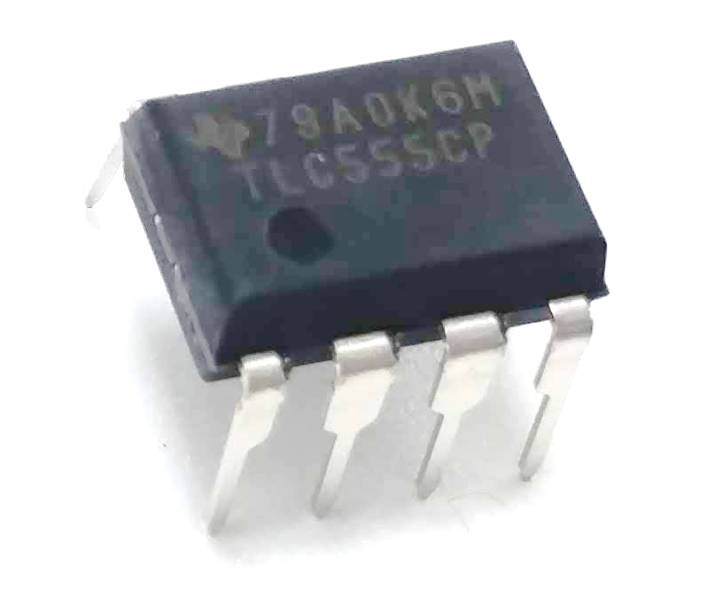

Pin 1 indicator

It is critical to install the IC correctly as installing it backwards may release all of the special magical smoke inside of the parts.

|  |
| --- |
| TLC555 Timer |

In case you overlooked this in the intro guide pins are number counterclockwise, like this: 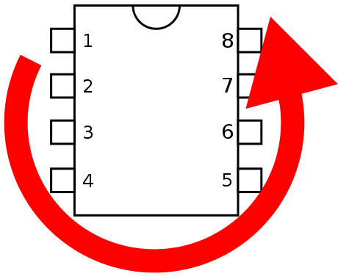

## Other parts

|  |  |
| --- | --- |
| Hookup wire | 9V battery clip |
| Mini phone (stereo) jack. Actual jack may be a different color. |  |

The 1/8” mini-phone jack has three tabs on the bottom that mate to the bread board. When viewed from front/above as shown in the photo below, the signal order is right, n/c, ground, n/c, left. Usually red indicates right and white indicates left, but on breadboard convention is also to use red for the positive power connections. Chose whatever color you want, but if you pick red, don’t wire it to power!

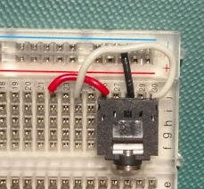

This circuit leaves the ring (red wire in the above picture) disconnected.

# The schematic

Don’t worry if you’re not familiar with reading schematics yet. As you do more circuits you’ll start to pick up on the way schematics represent the function of a circuit and the physical realization of that with actual parts. Google is your friend for finding many excellent tutorials on understanding schematics.

The 1/8” jack shown in the schematic has more connections than the jack that may be in your kit. That’s OK, we just need two wires to the jack, the tip (left if it was stereo) and the ground connection. Please see the ABW build kit introduction document for more details about using the 1/8” jacks.

This schematic is shown with the parts to make a unit that will connect to a high impedance line level input (mixer, pre-amp, etc); the output voltage is around 0.7V.

If you connect low impedance headphones the output level will be highly attenuated, so in the build directions we’ll tell you to use a different part for R2 (the 10K resistor).

It’s also possible to drive a small 16 ohm speaker directly but that’s outside the scope of this initial project.

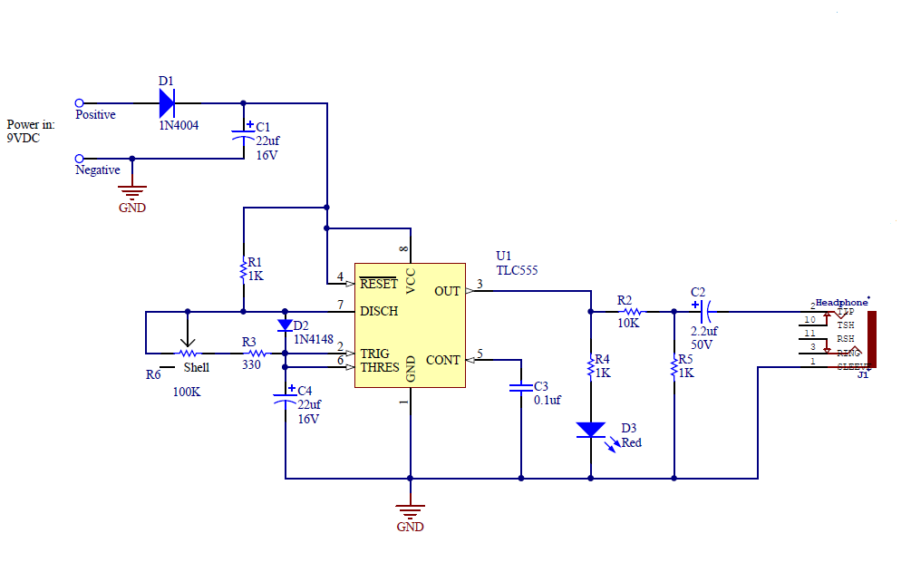

## Pictorial view

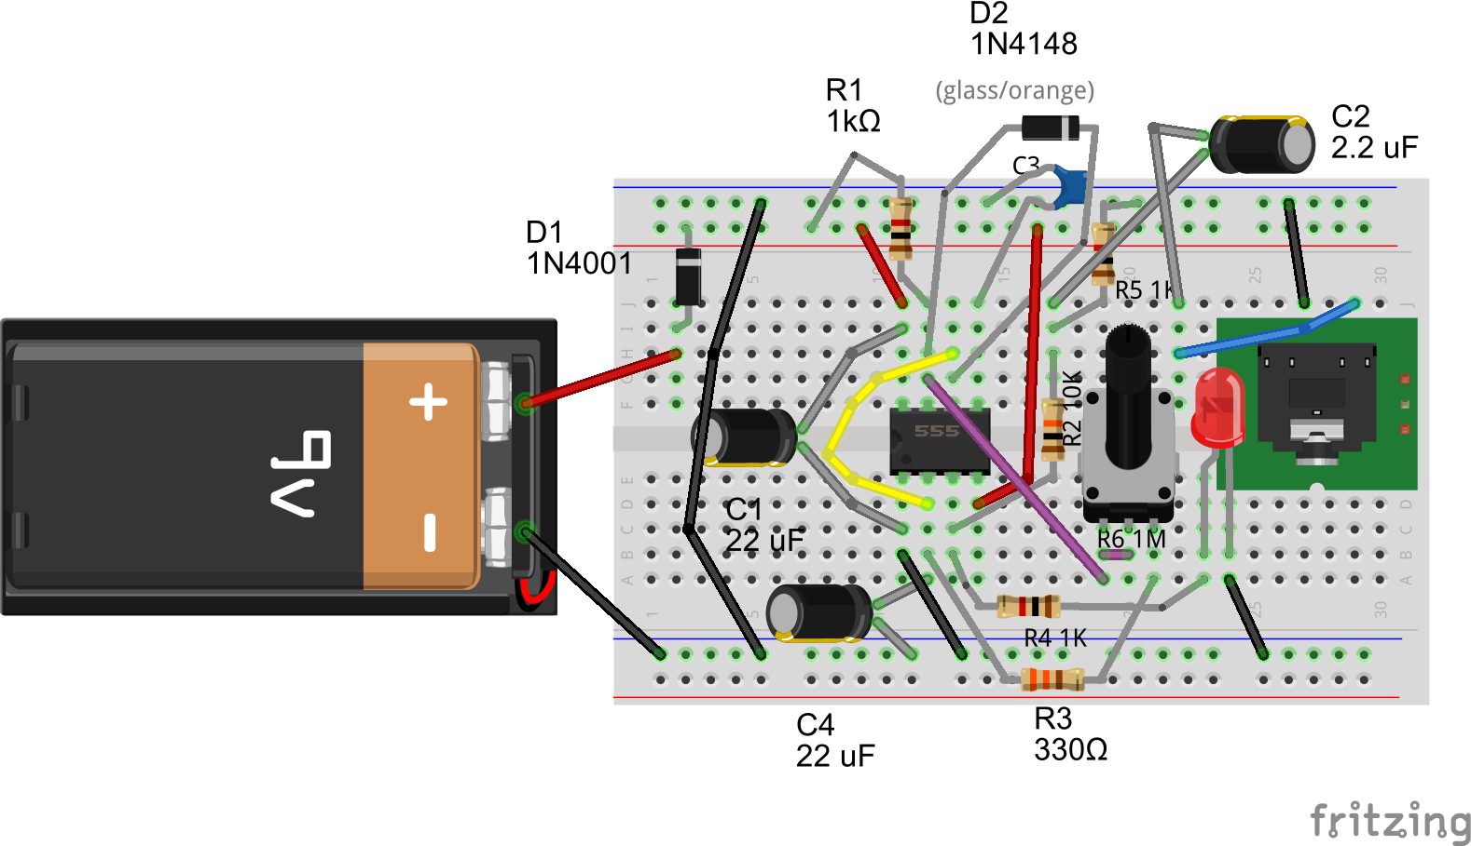

The pictorial view shows how the circuit could be constructed on the breadboard. There are many possible ways to place the components and wire them up that are all electrically identical to the schematic. If you’ve forgotten how a breadboard connects the holes together please review the supplemental materials.

Therefor anything needing a power connection can go in any hole on the red “rail” on the left of the above diagram. It can’t connect to the red rail on the right as no wire was placed to connect the two rails together.

In contrast, a (black) wire was added to connect the two negative (blue stripe) rails together, so a connection to negative (also called Ground in this circuit) can be made to either rail.

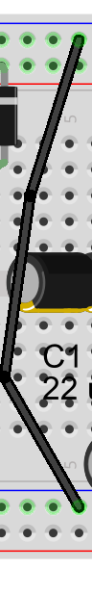

Detail of wire that connects the two sides for the negative (ground) connection.

# Overview of assembly steps

There’s really no one way to build these circuits. We do suggest you take out the parts you need ahead of time from the kit and put them in a separate box (or a plate if you’re at an event) so you know if you left out a part, etc.

Likewise it’s convenient to make up the wire jumpers you need before you start. You may need to cut a few more as you go but staying focused on the assembly steps is key to not overlooking anything.

The battery should be the very last thing you connect, and only after triple checking everything else.

## Things to think about before you start

Putting in ICs backwards - that might break them. Pay really close attention to when you put that part in.

Polarized capacitors also should not be connected backwards. If you connect the diodes backwards no harm will be done but the circuit won’t work.

Before you connect the battery check the IC and polarized cap again. And then ask a friend to check.

## And starting

Place the breadboard in front of you with column 1 on the left and column 30 on the right.

We’ll install the three main components first, and then start connecting them together, either with jumpers or with other components.

In electronics inputs are traditionally placed on the left and outputs on the right. You’ll notice the schematic was drawn this way too.

The first connection to make is a black wire that connects the two negative strips together (which are marked in blue on some breadboards). Do this in some out of the way place, usually near the first few columns is a good place.

Starting on the right side of the breadboard, plug in the miniheadphone jack so that you can still access a column of pins above it.

Next move a few rows to the right and plug the pot in. It has two large tabs that won’t fit in the board. You can place those in the gutter between the two rows (you may still need to bend the tabs or the pins slightly to make it all fit).

Next we’ll install the IC – if not wearing a grounding wrist strap, as a precaution, touch some metal (preferably grounded) before reaching for it. Move another 10 holes or so to the right. Arrange the IC so pin 1 is in the lower left as you face the board. This means the notch (or dot) is on the left – refer back to the earlier diagram if you’re unsure. We’ll use column 11 as that’s what the example drawing shows, but you can use any location that leaves enough room for the parts that need to go around it.

## Power connections and parts

We’ll add the battery clip (no battery should be connected!). Place the black wire in to one of the holes on the bottom negative strip (blue stripe). Place the red wire in to a row on the far left side, we’ll use row 2 in this example.

Take a 1N4001 diode (D1 is its ref-des in the schematic) and bend the leads so that one end will go in the positive rail at the top (red stripe) and the other end will go in a hole in row 2 on the upper half of the board (i.e. columns f-j). Insert the diode such that the stripe is on the side connecting to the positive power rail.

At this point your board should look something like the next diagram. We know the 1/8 mini-phone connector doesn’t quite look like what’s in the diagram but it’s what the Fritzing tool wants to show so we’re just going to go with it. A photo is also shown to help you review your layout.

Pin 1

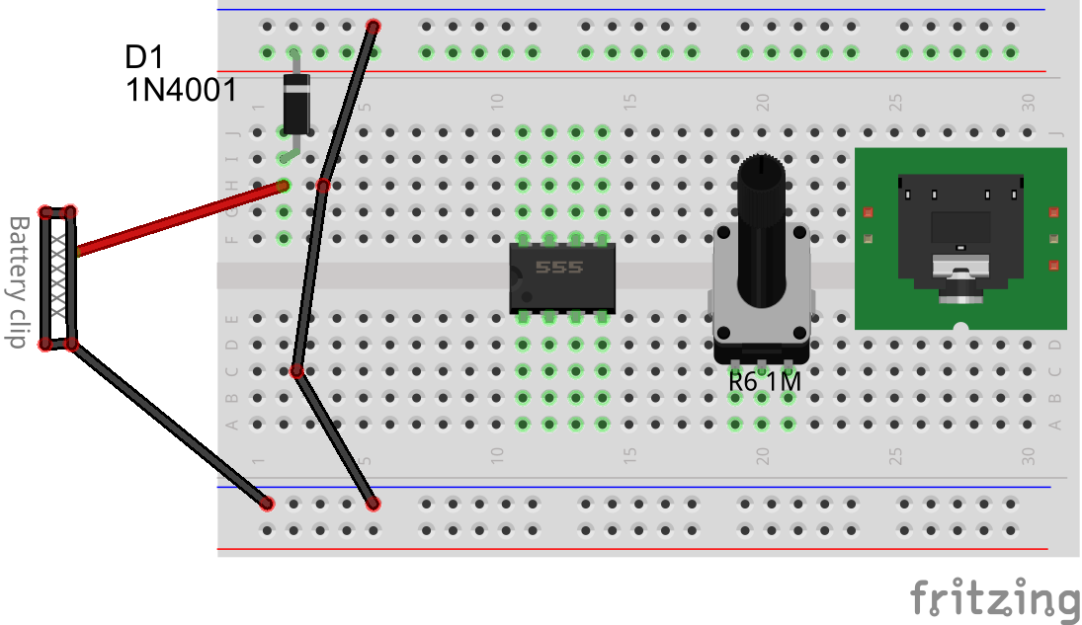

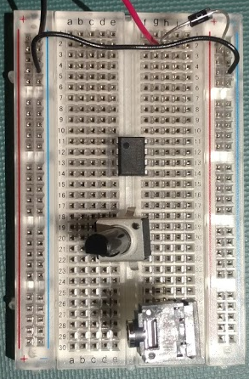

Next we’re going to connect the power pins of the 555 timer IC.

Using a small piece of red wire connect pin 8 (i.e. any hole in row 11 column f-j) to the red power rail. Using a small piece of black wire connect pin 1 (i.e. any hole in row 11 column a-e) to the blue (ground/negative) rail on the bottom (which is connected to the top negative rail, but we generally connect to the closest rail).

Pin 4 must also be connected to the positive rail as well. Use a piece of red jumper to connect a hole in row 14 (a-e) (where pin 4 of the IC is) to the positive (red) rail at the top.

Now install C1, a 22 uF capacitor. The positive lead connects to pin 8 of the IC, and the negative lead to pin 1 of the IC. You must observe the polarity of C1.The Fritzing diagram shows this as black but in the kit the part is most likely red.

Next install C3, a 0.1 uF ceramic capacitor, from pin 5 (row 14, column f-j) to the ground rail at the top. In the Fritzing diagram this shows as blue, but in the parts kit it’s most likely yellow. It is labeled 104.

Your board will now look something like this.

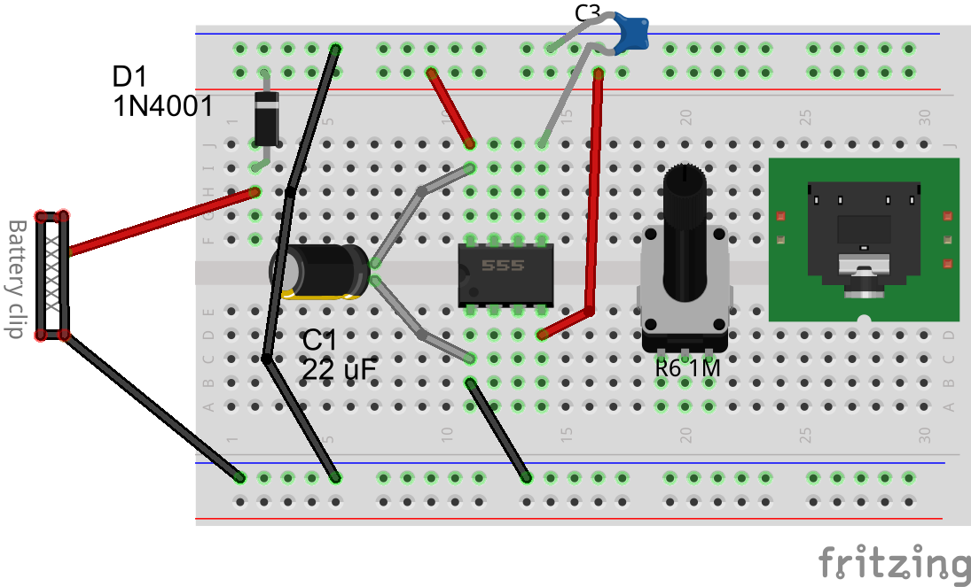

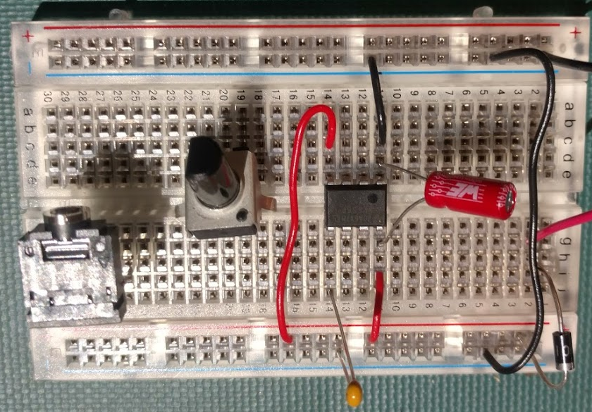

## Connect the 555 to the rest of the components

With the basics complete we’ll now connect up everything else. Make sure component leads are arranged to not short against other components. We’ll work left to right across the schematic.

First install R1 (1KΩ : Brown Black Red) between pin 7 and the positive rail at the top.

Next install a jumper wire (any color you want, we used purple in the drawing) from pin 7 to the left terminal of the pot (row 19). Then install a jumper wire to connect the left and center pin of the pot.

Install R3 (330Ω: Orange Orange Brown) between the right terminal of the pot and pin 2 of the IC.

Using a small jumper wire (yellow in the example diagram) connect pin 2 to pin 6 of the IC.

C4 (22 uF) is polarized device so the positive pin connects to pin 2 of the IC and the negative lead to the negative (ground) rail (blue stripe).

D2, the 1N4148 diode, is polarized and must be installed as described. Note that in the diagram D2 shows as a part with a black body, but it’s actually an orange glass body as shown in the parts guide.[1] Connect the striped end of the diode to pin 6 of the IC, and the other end to pin 7.

This completes the left side of the schematic being wired, so a good time to check your board against the diagram.

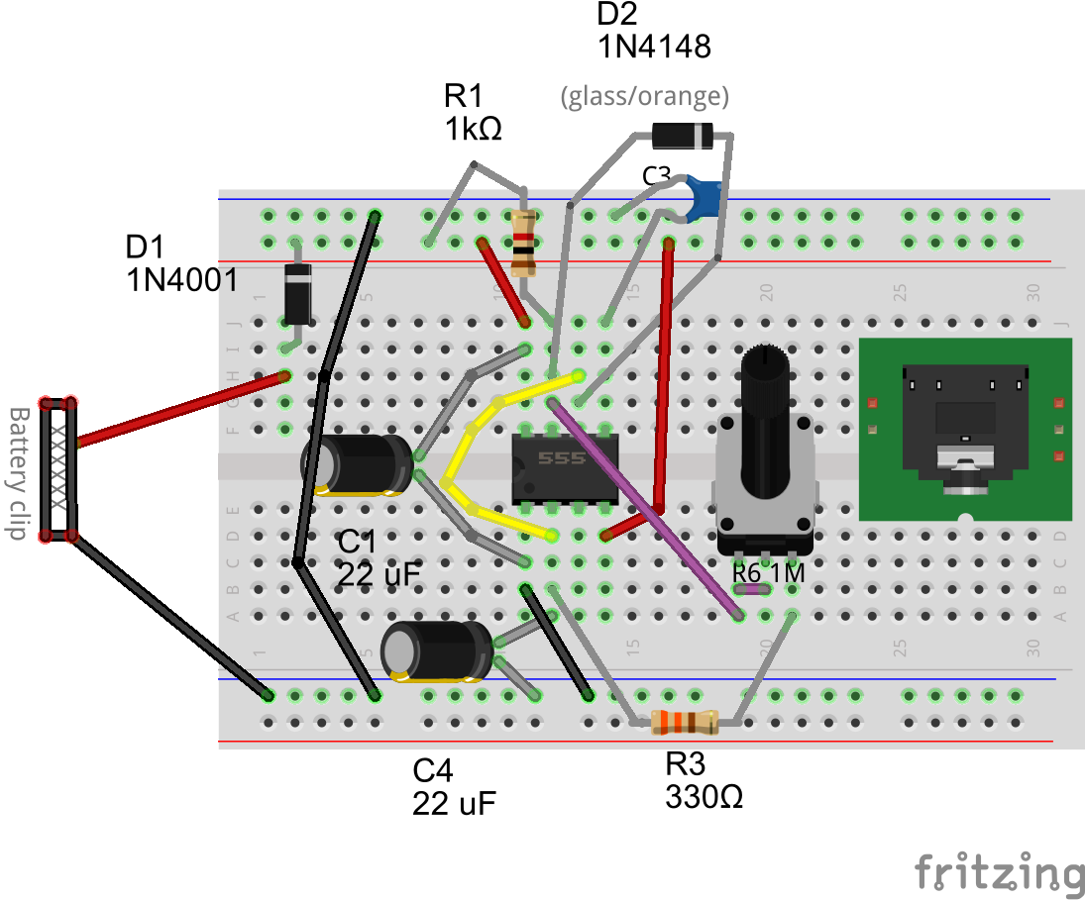

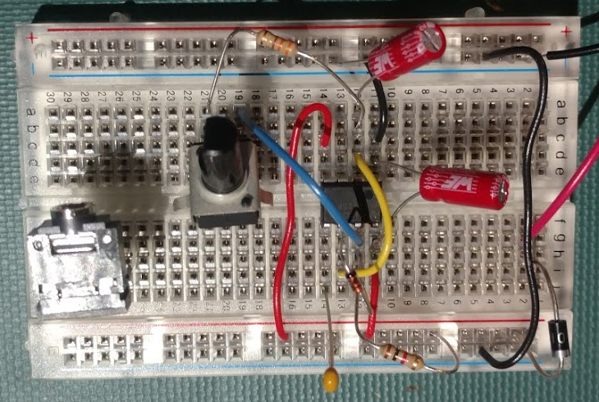

The last part of the construction is to connect up the output of the 555 IC, which is pin 3.

Install the RED LED (D3) in a convenient place, we’ll use rows 23 and 24, with the cathode side (the side with the flat/notch on it) on the right, i.e. row 24. Connect the cathode of D3 (the flat side of the LED) with a short black jumper to the negative (ground) rail (blue stripe).

Install R4 (1KΩ : Brown Black Red) between the anode side of the LED (row 23) and pin 3 of the IC.

For this next step we’re going to use a blank row to connect 3 components together. In the example diagram this is row 17. Install R2 (10KΩ : Brown Black Orange) between pin 3 of the IC and row 17. Then install R5 (1KΩ : Brown Black Red) between row 17 and the negative (ground) rail at the top (blue stripe). We next need to wire C2 to the output jack, but it won’t reach so we’ll use another blank row and a wire jumper to complete the connection.

Install C2 (polarized) with the positive side connected to row 17 and the negative side to an adjacent row, in the example diagram row 22 was used. Then use a short jumper wire (blue in the example diagram) to connect row 22 to the “tip” jack connection, which is the right side in the example.

The last connection is the jack’s ground connection (middle pin), a short black jumper should be used to connect it to the negative (ground) rail at the top (blue stripe). Be careful to use the correct rows for the jack – it’s easy to be off by a row.

Your board should now look like the diagram provided at the beginning of the build section, and as shown in the picture below.

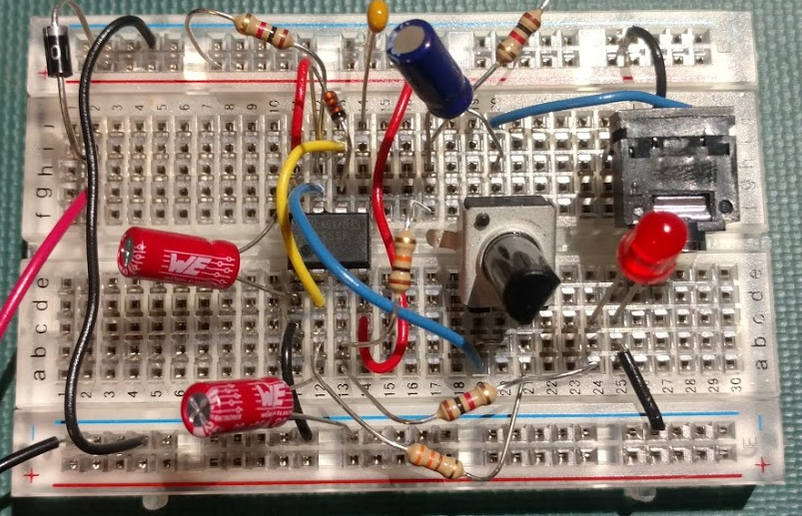

Do not install the battery yet.

## Check your work

Verify the battery clip red and black leads connect as shown.

Verify the polarity of the three electrolytic capacitors.

Verify the diodes are connected correctly with the cathode band indicator to the proper spot.

Look for shorts between component leads.

Look for wires stuck in “off by a row”.

## Test it

Connect the output to an appropriate amplifier/speaker and set the volume to zero. Remember the output is mono.

Connect the 9V battery. The LED should flash. Rotate the tempo knob for a rate of about 1 beat/sec. Then slowly turn up the amplifier volume. Adjust the volume to the desired level and the tempo to the desired speed. Make sure you turn the knob through its full rotation – towards the end of it’s rotation the tempo will be very, very, slow.

If you have sound but the LED is not flashing most likely the LED is installed backwards. Review your connections.

# TRY THIS

## Using headphones in place of AN amplifier AT the output

The high output impedance of this circuit results in a low signal level in headphones, but it should still be audible. Remember that with the mono output it will only be heard in the left side.

For a louder signal disconnect the batter and replace the 10KΩ resistor R2 (connected between pin 3 and row 17) with one of the extra 1KΩ you took out at the start.

Reconnect the battery and the signal should be much louder. If it’s not loud enough you can reduce the value of resistor R2 to 330Ω; this shouldn’t be needed unless the headphones in question are both very low impedance and have low sensitivity.

Congratulations – you have just hacked the original design (line level output) to do something else (drive a headphone). Though a trivial example, it does show easy breadboards are for experimenting with different ideas.

## Changing the range of tempos

The 1MΩ pot results in very slow tempos (seconds per beat) for most of its rotation. You can change the range by replacing the 1MΩ pot with the 10KΩ pot. Another way to change the range is to replace C4 (22 uF) with a 2.2uF capacitor instead. R3 (330Ω ) can be replaced with a large value to shift the range as well (do not use a lower value), it will have most effect with the 10KΩ pot.

You can read more on-line about how the resistor and capacitor values set the rate that the 555 IC oscillates.

# The good stuff

This document and all of the source files associated with this project are Copyright 2018 by the Audio Builders Workshop (ABW).

<https://www.facebook.com/groups/AudioBuildersWorkshop/>

a working group of the Boston AES

<http://bostonaes.org/>

All materials are licensed by the ABW under the Creative Commons Attribution-Share-Alike license CC-BY-SA: <https://creativecommons.org/licenses/by-sa/4.0/legalcode>



Design and this part of the documentation developed by Clockworks Signal Processing LLC for ABW.



<http://clk.works/>

1. Fritzing, the design package used for the pictures, didn’t have a simple way to fix this at the time we developed the documentation.